**Comparison Between GPT-4 and BERT**

**First: GPT-4 Model**

**1. Definition:**

* **GPT-4 (Generative Pre-trained Transformer 4) is a large generative language model based on the Transformer architecture, designed to produce human-like text. It has been trained on massive amounts of textual data.**
* **GPT-4 is a new language model created by OpenAI that is a** **large multimodal that can accept image and text inputs and emit outputs. It exhibits human-level performance on various professional and academic benchmarks.**

**2. Architecture:**

* **Transformer Decoder:** GPT-4 relies solely on the Decoder part of the Transformer architecture.
* **Self-Attention Mechanism:** It uses self-attention to process text, enabling the model to understand word relationships based on context.
* **Auto-Regressive Encoding:** GPT-4 generates each word based only on the preceding words, making it highly effective for text generation tasks.
* **Number of Layers:** It consists of a very large number of layers (e.g., 96 layers in GPT-3, with even more expected in GPT-4).
* **Attention Heads:** It has a high number of attention heads, enhancing the model’s ability to focus on different aspects of information.

## 3. Understanding GPT-4 Architecture:

* The architecture of GPT-4 marks a significant departure from previous models by adopting a mixture of experts (MoE) design, which enhances both scalability and specialization. Unlike the standard transformer approach, the MoE model comprises multiple expert neural networks, each specialized in specific tasks or data types. This structure allows GPT-4 to handle complex queries more efficiently.
* According to industry reports, training GPT-4 required substantial computational resources, utilizing around 25,000 NVIDIA A100 GPUs over 90 to 100 days and a dataset of approximately 13 trillion tokens. For inference, the model operates on clusters of 128 A100 GPUs.
* **Key aspects of GPT-4’s architecture include:**
* **Total parameters:** Industry experts estimate that GPT-4 uses approximately 1.8 trillion parameters, over ten times more than GPT-3.
* **Model composition:** The model consists of 16 expert models, each with approx. 100 billion parameters. For any given inference query, two expert models are activated. The model uses around 50 billion shared parameters for attention mechanisms.
* **Inference efficiency:** During inference, only a subset of the model’s parameters is utilized, amounting to about 280 billion parameters per query.
* **The MoE design offers two primary benefits:**
  + **Scalability:** By routing inference through only the relevant expert models, the overall system can scale significantly without prohibitive inference costs.
  + **Specialization:** Each expert model can develop specialized knowledge, enhancing the model’s overall capabilities and performance.

**4. Use Cases:**

* **Text-Based Tasks:**
  + Text Generation
  + Machine Translation
  + Question Answering
  + Creative Content Creation (e.g., stories, articles)
  + Conversational AI and Chatbots
  + Code Generation and Debugging
  + Summarization and Paraphrasing
  + Text Completion and Autocorrect
  + Sentiment Analysis
  + Data Analysis and Insight Extraction
  + Virtual Assistants
  + Educational Support and Tutoring
  + Knowledge-Based Reasoning and Research Assistance
* **Multimodal Tasks:**
  + Image Captioning and Interpretation
  + Visual Question Answering
  + Image Generation and Enhancement
  + Speech Recognition and Generation
  + Audio Analysis and Classification
  + Video Analysis and Content Understanding

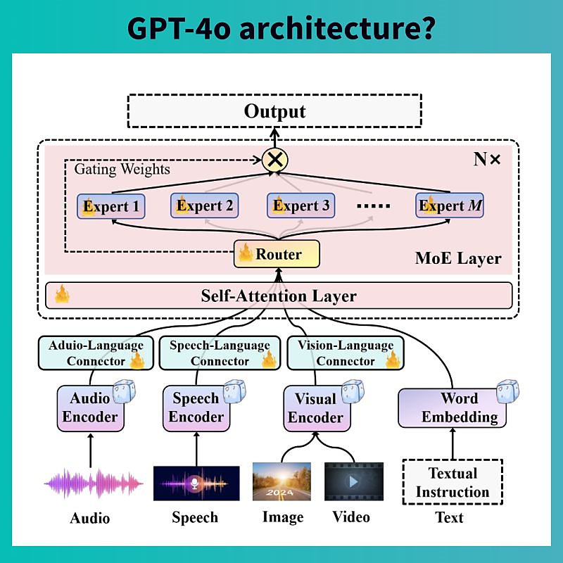

**Second: BERT Model**

1. **Definition:**

* **BERT (Bidirectional Encoder Representations from Transformers) is a model based on the Transformer architecture, mainly used for text understanding and analysis.**
* **BERT, short for Bidirectional Encoder Representations from Transformers, is a Machine Learning (ML) model for natural language processing. It was developed in 2018 by researchers at Google AI Language and serves as a swiss army knife solution to 11+ of the most common language tasks, such as sentiment analysis and named entity recognition.**

1. **Architecture:**

* **Transformer Encoder:** BERT uses only the Encoder part of the Transformer architecture.
* **Bidirectional Processing:** It understands text by looking at both preceding and succeeding words in a sentence, leading to better comprehension of full meaning.
* **Pre-training Tasks:** BERT is pre-trained on tasks like Masked Language Model (MLM) and Next Sentence Prediction (NSP).
* **Number of Layers:** BERT-Base consists of 12 layers, while BERT-Large has 24 layers.
* **Attention Heads:** BERT-Base has 12 attention heads, and BERT-Large has 16 attention heads.

**3. Understanding BERT Architecture:**

* BERT’s architecture is based on the traditional Transformer Encoder design, which processes text bidirectionally to capture context from both preceding and succeeding words in a sentence.
* Unlike GPT-4’s mixture of experts, BERT uses a dense, fully connected architecture where all parameters contribute to every inference, making it highly effective for understanding language nuances but more resource-intensive for large-scale tasks.
* Key aspects of BERT’s architecture include:
  + **Total parameters:** BERT-Base has 110 million parameters, while BERT-Large has 340 million parameters.
  + **Model composition:** A dense transformer architecture where each layer processes all input data simultaneously.
  + **Training methodology:** Pre-trained on masked language modeling (MLM) and next sentence prediction (NSP) to develop a deep understanding of textual relationships.
  + **Inference efficiency:** Uses the entire model’s parameters for each inference, offering comprehensive but potentially slower performance compared to MoE designs.
* BERT’s dense architecture offers two primary benefits:
  + **Contextual Understanding:** Bidirectional training enables the model to capture richer, more nuanced language representations.
  + **Versatility:** Excels at a wide range of natural language processing (NLP) tasks without needing specialized sub-models.

**4. Use Cases:**

* Text Classification
* Sentiment Analysis
* Information Extraction
* Question Answering

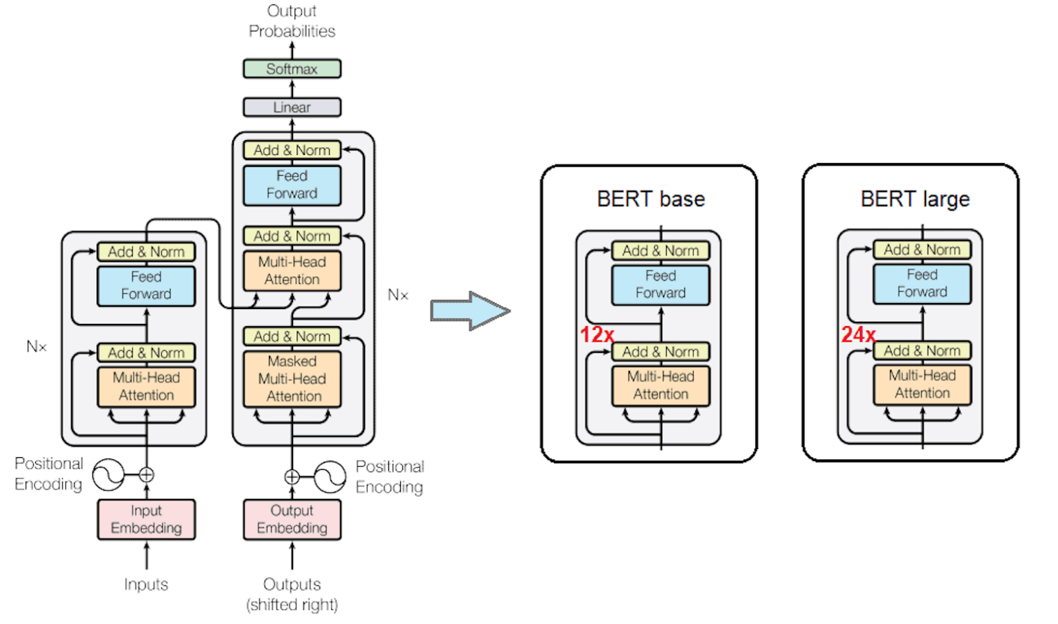

**Quick Comparison:**

| **Criterion** | **GPT-4** | **BERT** |
| --- | --- | --- |
| **Architecture Type** | **Transformer Decoder** | **Transformer Encoder** |
| **Processing Direction** | **Unidirectional** | **Bidirectional** |
| **Generation Method** | **Auto-Regressive** | **Masked Language Model** |
| **Number of Layers** | **Very High (96+)** | **12 (Base) or 24 (Large)** |
| **Attention Heads** | **Very High Number** | **12 (Base) or 16 (Large)** |
| **Primary Use Case** | **Text and Multimodal Data Generation and Understanding** | **Text Understanding** |

